**SPA BOOKING SYSTEM**

**Name:Priyadharshini Murugan**

**EmpId:11985**

**Case Study 5: Spa Booking System**

Online spa booking application that allows clients to schedule appointments, make payments, and access

You will get the list of services in detail with pricing as

well so that you can choose the type of service you want and can book in advance.

**Features:**

→ **Appointment Booking:** Simplify appointment scheduling, reduce phone calls, and enhance

convenience for clients.

→ Client Management: Store essential client information securely.

→ Virtual Consultations: Enable remote consultations for personalized treatment recommendations.

→ See the customer reviews

|  |  |
| --- | --- |
| WHAT | HOW |
| **What are the modules required for the spa booking system?**    **1. User Registration**   * Customer can register by using their credential   **2. Appointment Booking**   * Allows the clients to schedule their appointments online   **3. Client Management**   * Stores client information securely for future reference   **4. Virtual Consultation**   * Enable remote consultation for personalized treatment recommendations   **5. Customer reviews**   * Displaying customer reviews for spa customer enhancements | *1.User Registration*  *Method1:* Users can register using their credentials like   * Name * Age * Email * Phone number   And login with just email and password  *Method2:* Users can register using their social media account  *2. Appointment Booking*  *Method1:* Bookings can be made by clicking Booking option by filling their   * Name * Age * Email * Allergy specification (if any)   in a form and they can be able to choose the services they want from   * Dropdown.   *Method2:* By placing Book Now option under each image service, customers can click it and redirect to booking page and they need to fill the details down below in form.   * Date * Time * Allergy specification (if any)   *3.Client Management*  *Method1:* When users register by using their   * Name * Email   it will get stored in MySQL database and later it will be displayed in admin dashboard for admin reference  *Method2:* When users register by using their   * Name * Email   it will get stored in MySQL database and it will be displayed in homepage |

|  |  |
| --- | --- |
|  | *4.Virtual Consultation*  *Method1:* After clicking Consultation, Users can be able to book virtual consultation through the chat box by giving their credentials like   * Name * Email * Description   And those details will be displayed in admin page so admin will be able to send a Gmeet link through the email.  *Method2:* Integrate video conferencing software to facilitate remote consultations between clients and spa professionals.  *5.Customer reviews*  *Method1:* Customers can give feedback by clicking feedback option and redirect to another page with feedback form.  *Method2:* Feedback section will be placed at last of homepage like a comment section where customers can be able to send their commands by giving their   * Name * Email * Comments   And it will be displayed in homepage |

|  |  |
| --- | --- |
| WHY | WHY NOT |
| *1.User Registration*  *Method1:* Users can register using their credentials like   * Name * Age * Email * Phone number and login with just email and password   ***REASON:* This method will be user friendly way for customers to register** | *Method2:* Users can register using their social media account  ***REASON:* This method will not be safety for customers to use and they hesitate to use their social media** |
| *2. Appointment Booking*  *Method2:* By placing Book Now option under each image service, customers can click it and redirect to booking page and they need to fill the details down below in form.   * Date * Time * Allergy specification (if any)   ***REASON:*  This method will make it easy for users to book appointments according to the service they want.**  *3.Client Management*  *Method1:* When users register by using their   * Name * Email   it will get stored in MySQL database and later it will be displayed in admin dashboard for admin reference  ***REASON:* This method will be suitable for security purpose**  *4.Virtual Consultation*  *Method1:* After clicking Consultation, Users can be able to book virtual consultation through the chat box by giving their credentials like   * Name * Email * Description   And those details will be displayed in admin page so admin will be able to send a Gmeet link through the email.  ***REASON:* This method will be cost-effective and user friendly** | *Method1:* Bookings can be made by clicking Booking option by filling their   * Name * Age * Email * Phone number * Allergy specification (if any)   in a form and they can be able to choose the services they want from   * Dropdown.   ***REASON:*** **This method will not be liked by most of the users**  *Method2:* When users register by using their   * Name * Email   it will get stored in MySQL database and it will be displayed in homepage  ***REASON:* It may raise security issues cause displaying users detail in homepage**  *Method2:* Integrate video conferencing software to facilitate remote consultations between clients and spa professionals.  ***REASON:*  This method will be more expensive and complex to build** |

|  |  |
| --- | --- |
| *5.Customer reviews*  *Method2:* Feedback section will be placed at last of homepage like a comment section where customers can be able to send their commands by giving their   * Name * Email * Comments   And it will be displayed in homepage  ***REASON:* This method will be easy for customers to write their reviews** | *Method1:* Customers can give feedback by clicking feedback option and redirect to another page with feedback form.  ***REASON:* This method will be tedious process for customers to write their reviews** |

**UML DIAGRAM:**

**Class Diagram:**

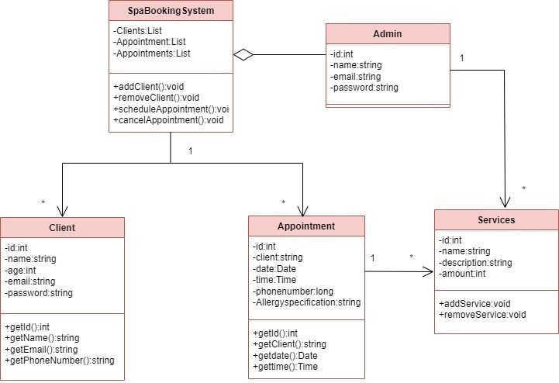

**use Case Diagram:**

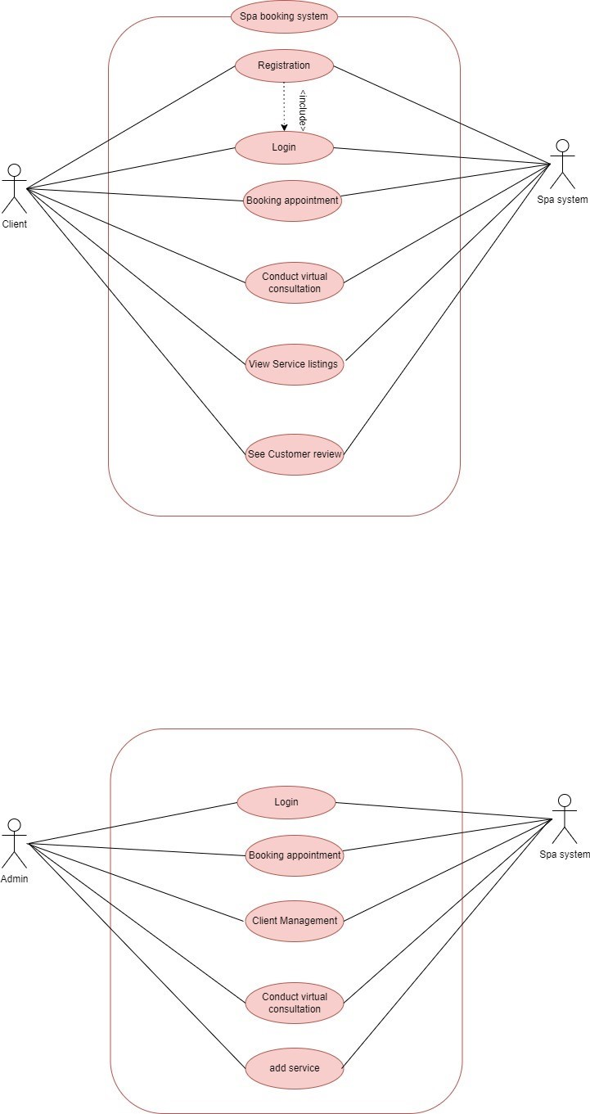

**sequence Diagram:**

**Login:**

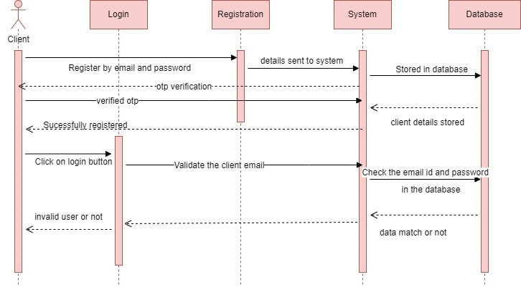

**Booking:**

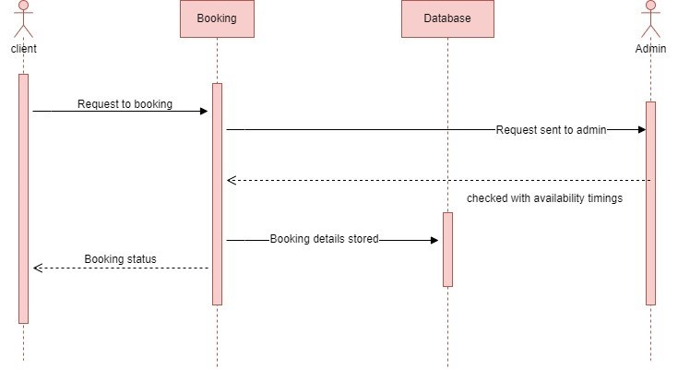

**UI WIREFRAME:**

1. **Home Page:**

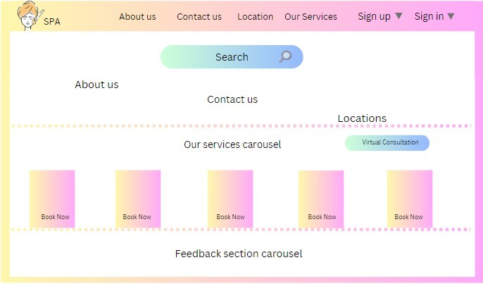

**.Sign Up page:**

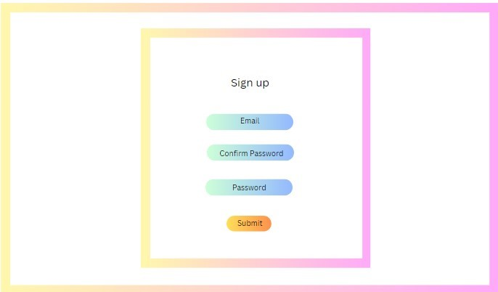

**3.Sign In page:**

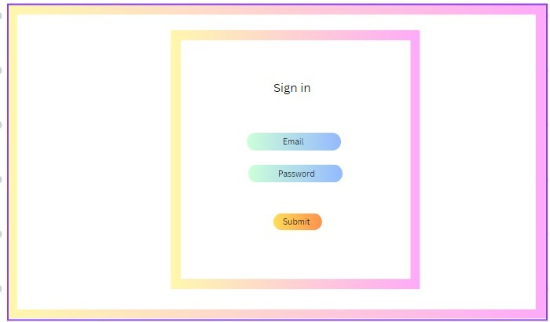

**4.Booking Appointment page:**

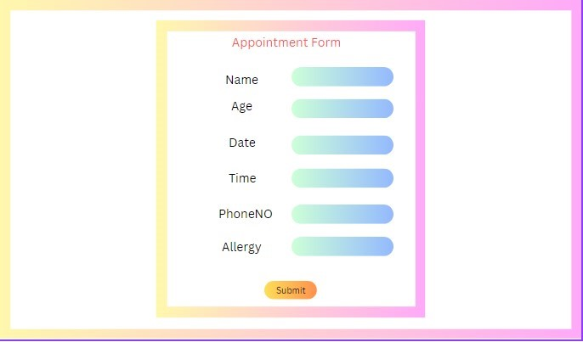

**5.Booking History Page:**

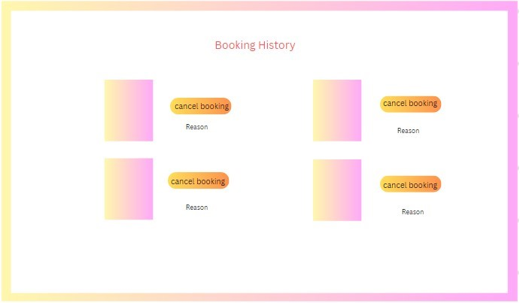

**6.Admin page:**

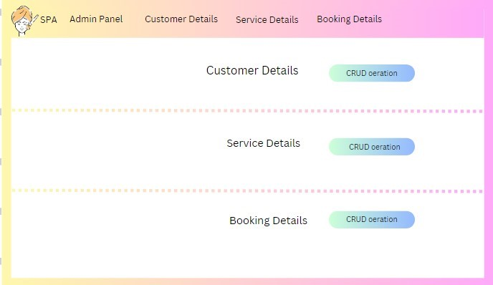

**ER DIAGRAM:**

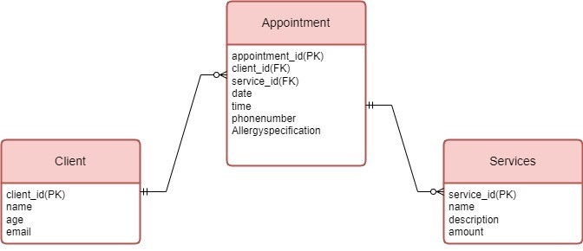

**EXPLANATION:**

* **One Client can use many Appointments**
* **One Appointment can have multiple Services**

**PROJECT :**

**SIGN UP PAGE:**

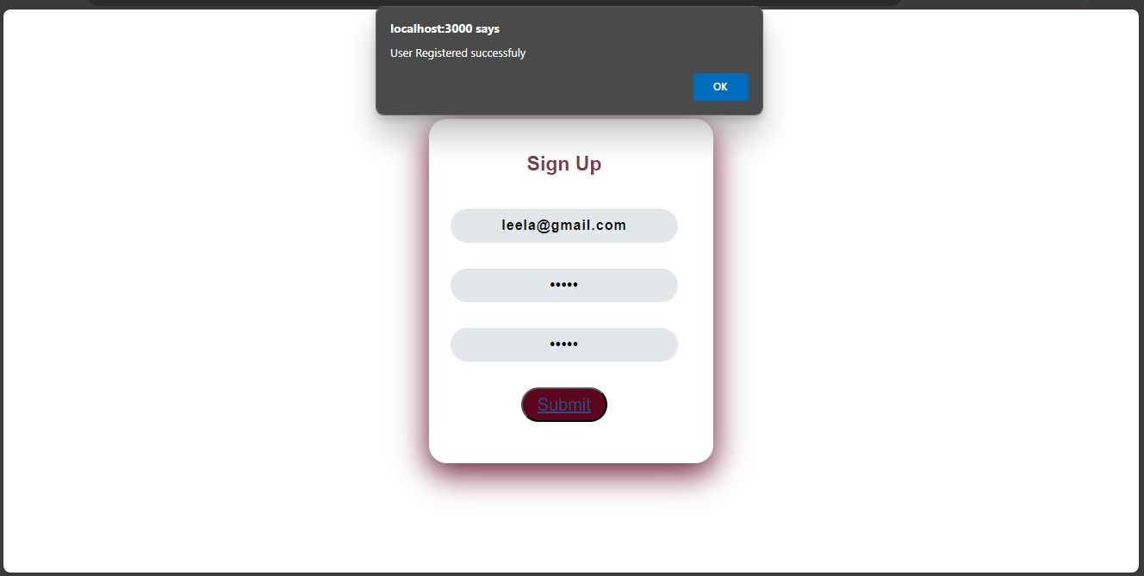**SIGN IN PAGE:**

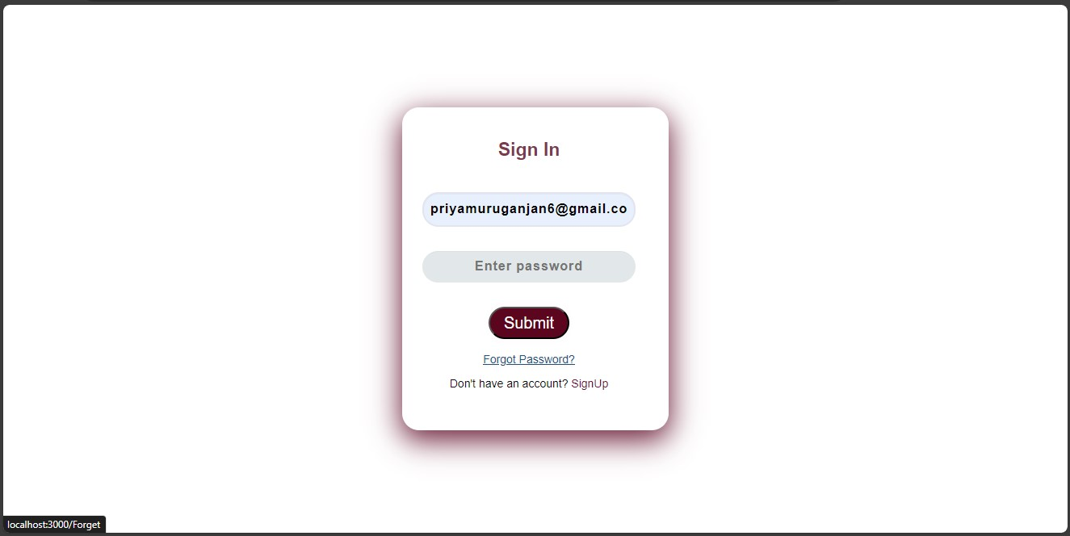

**HOMEPAGE:**

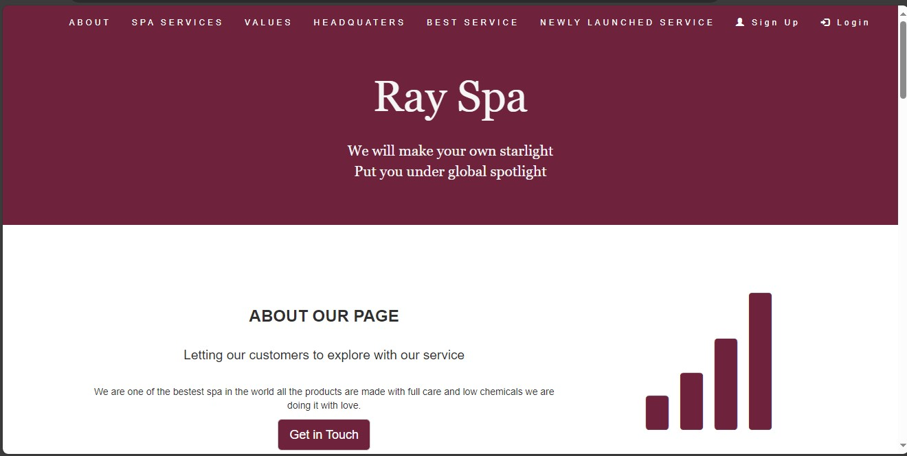**IF WE START** **SCROLLING IT GOES LIKE THIS:**

**ABOUT :**

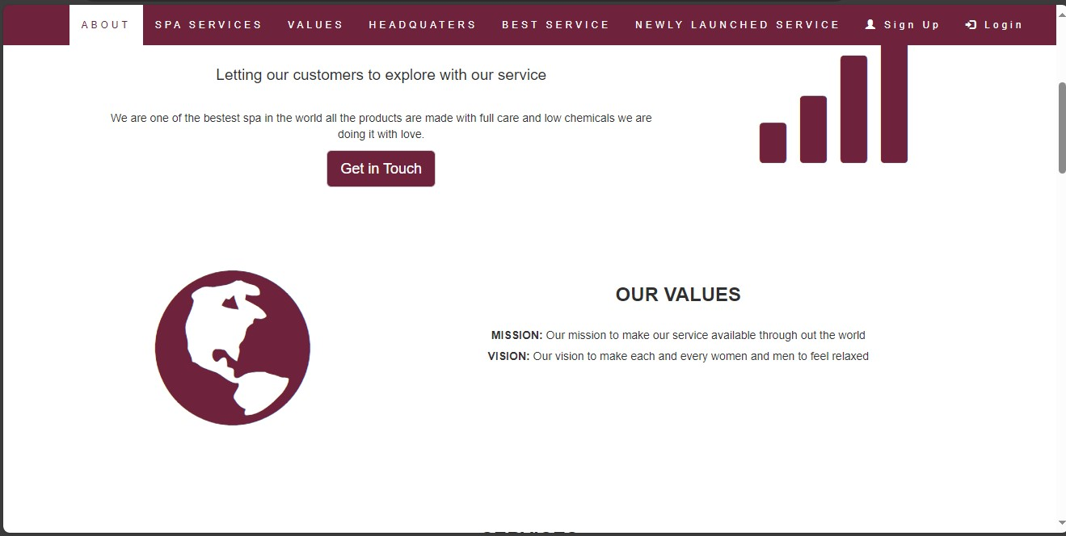

**VALUES:**

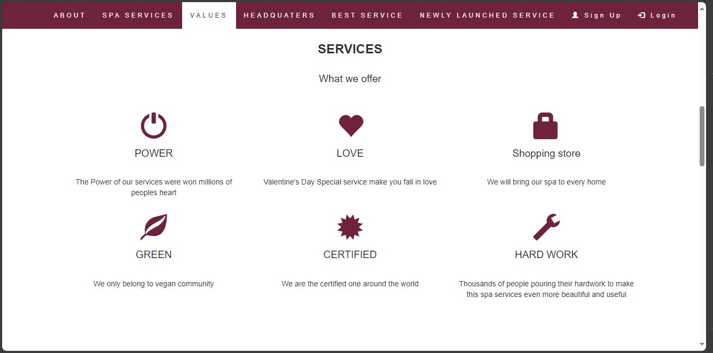**HEADQUATERS:**

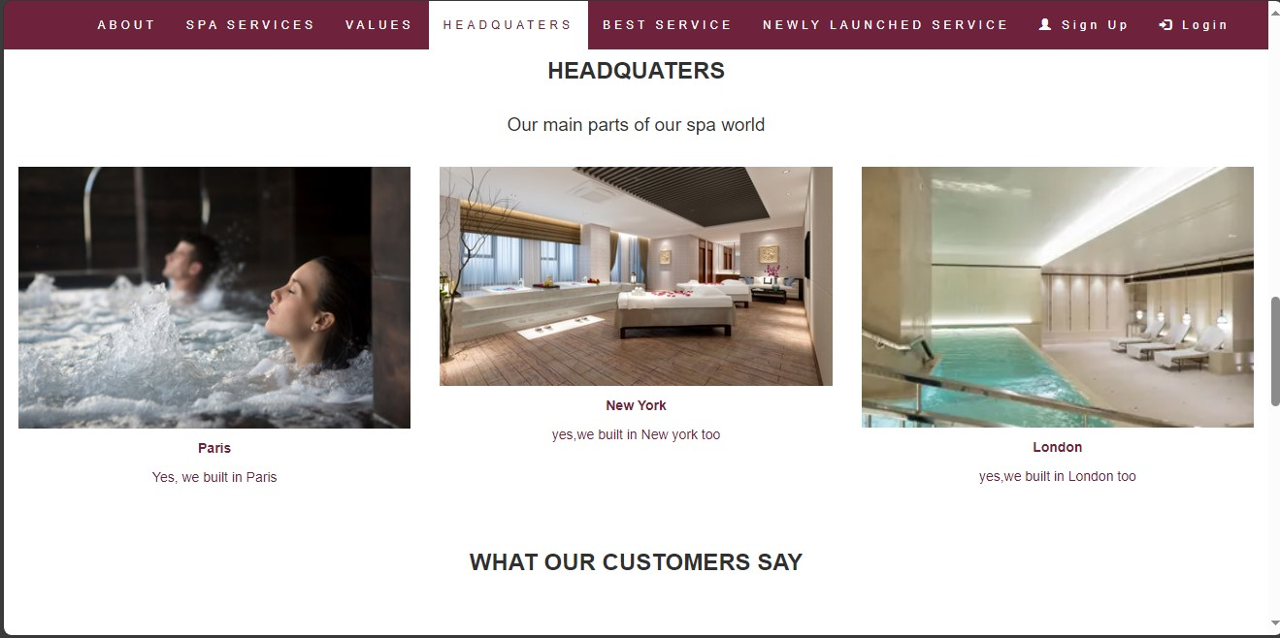

**NEWLY LAUNCHED SERVICE:**

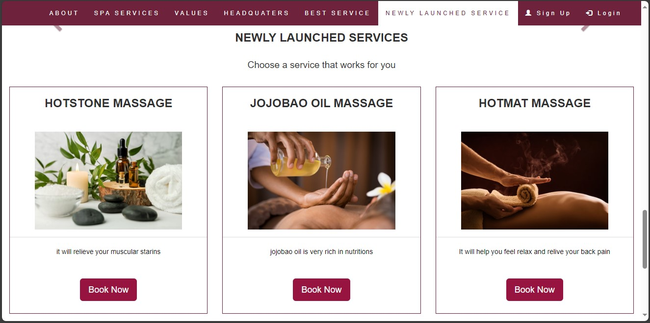

**CUSTOMER FEEDBACK:**

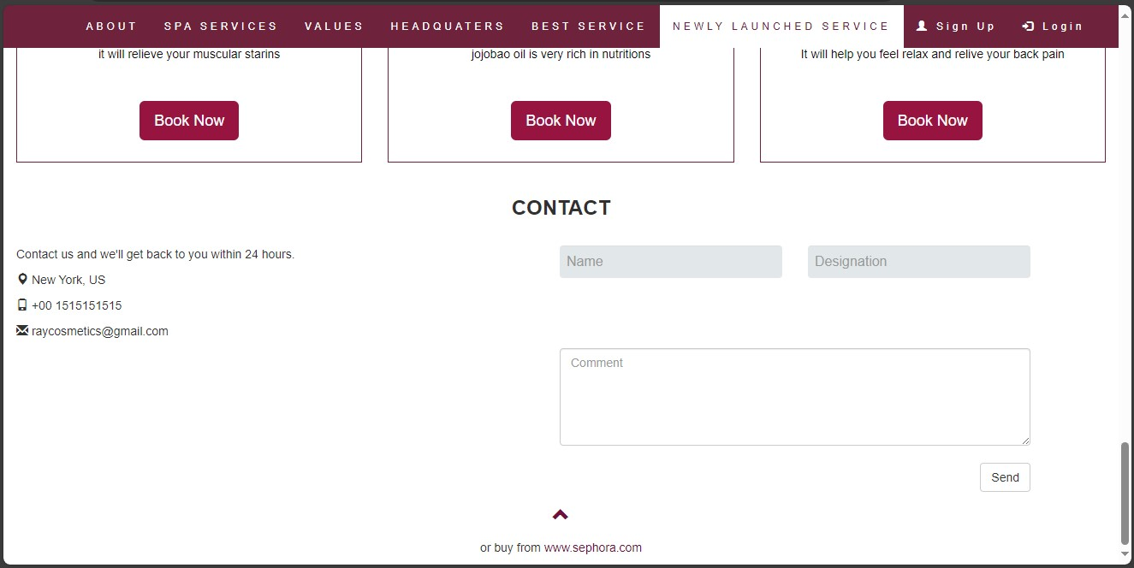

**IF CUSTOMER WRITE FEEDBACK ON FEEDBACK SESSION:**

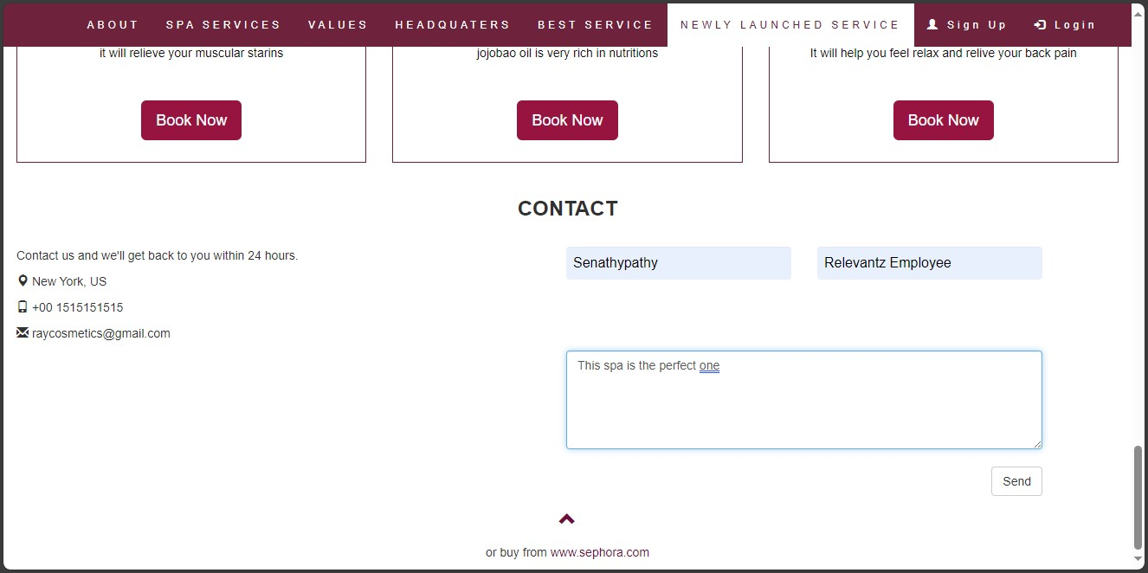

**FEEDBACK DISPLAY:**

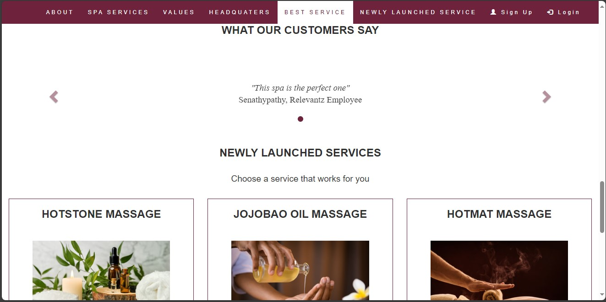

**ONCE WE CLICKED SPA** **SERVICE IT WILL TAKE US SERVICE PAGE:**

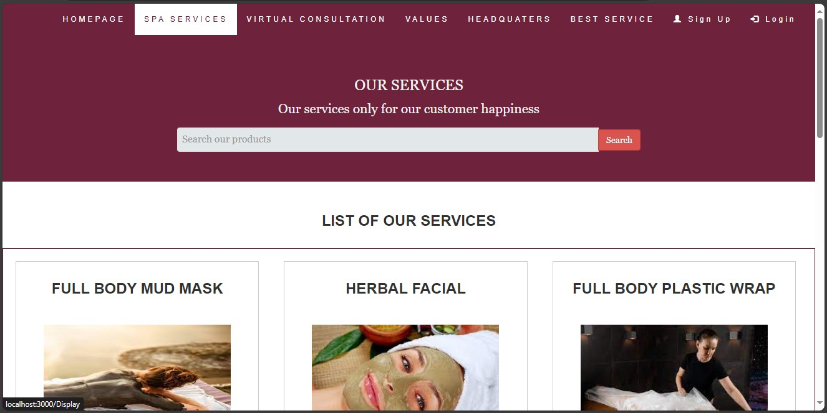

**IF WE SEARCHED “HOT” ON SEARCH BAR:**

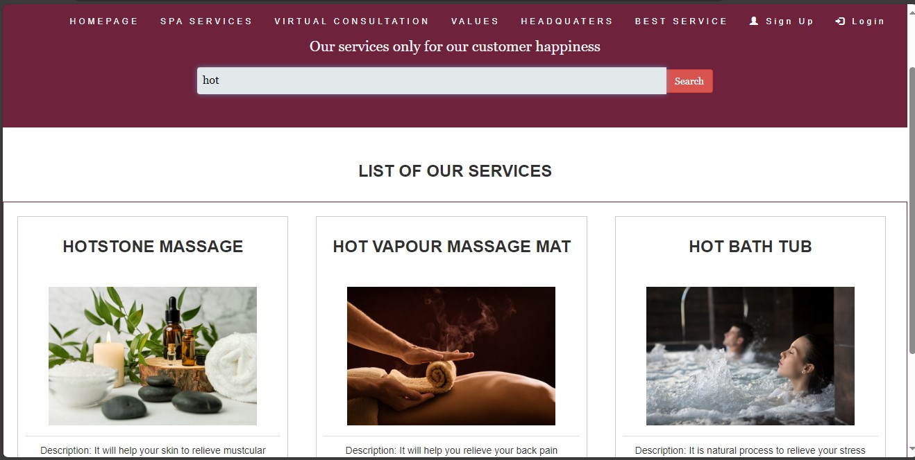

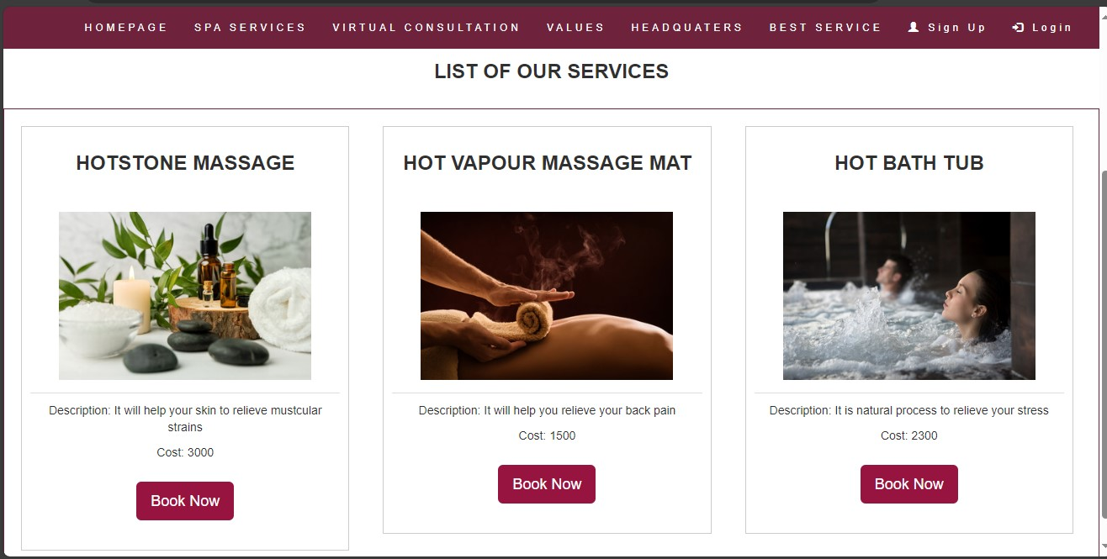**IF WE CLICK BOOK NOW BUTTON:**

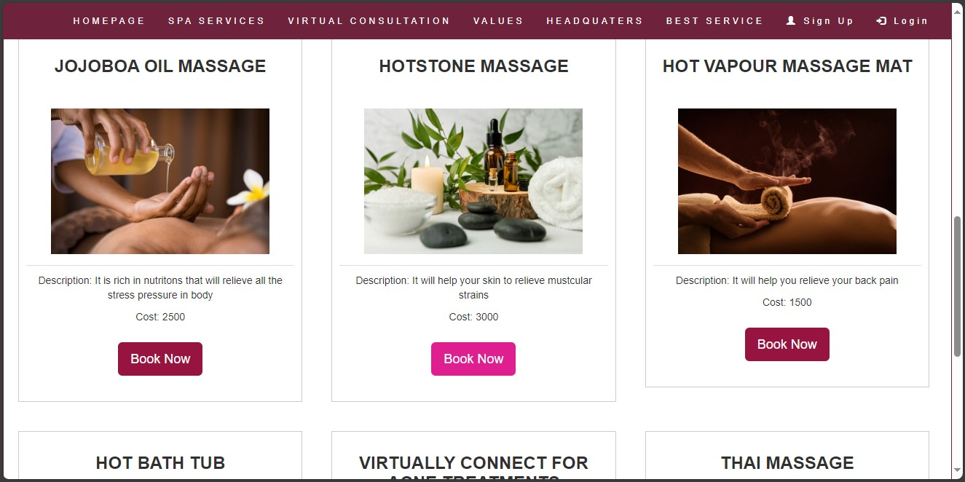**IF YOU ARE NOT SIGNED IN** **IT WILL TAKE YOU TO SIGN IN PAGE OR ELSE APPOINTMENT PAGE:**

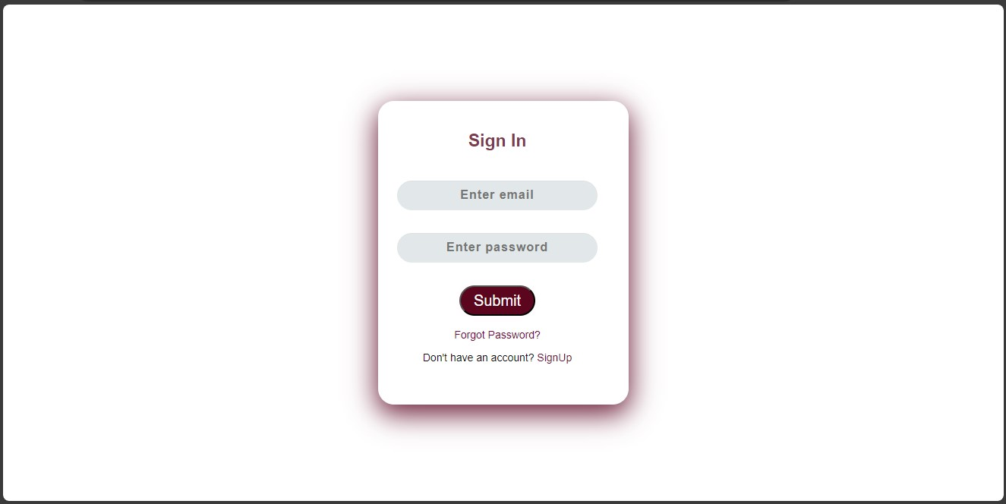**APPOINTMENT PAGE:**

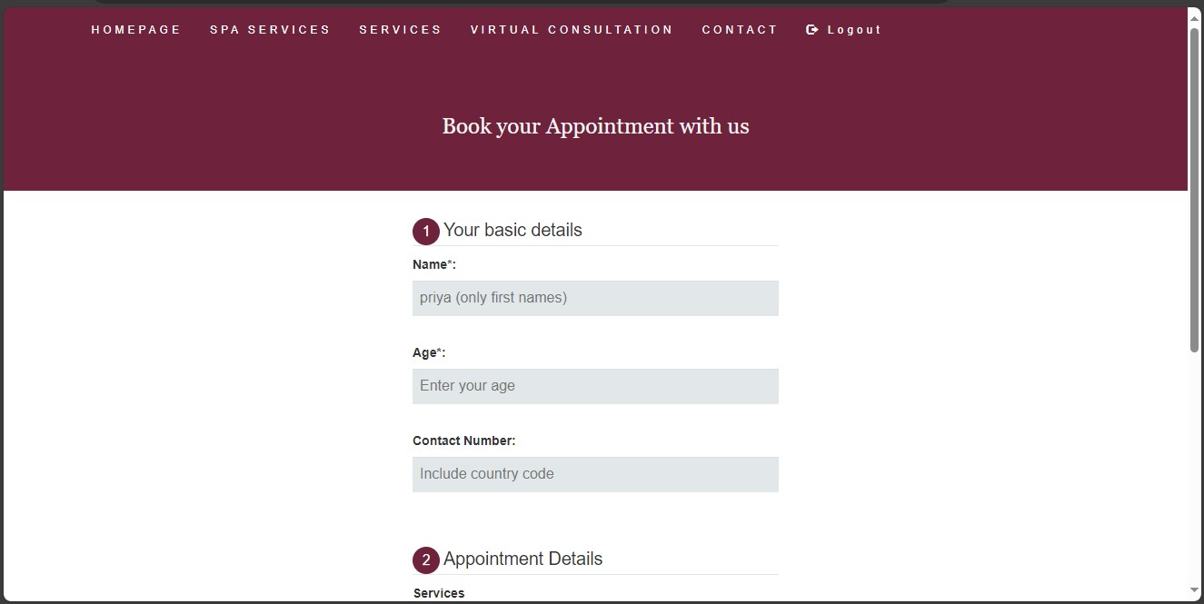

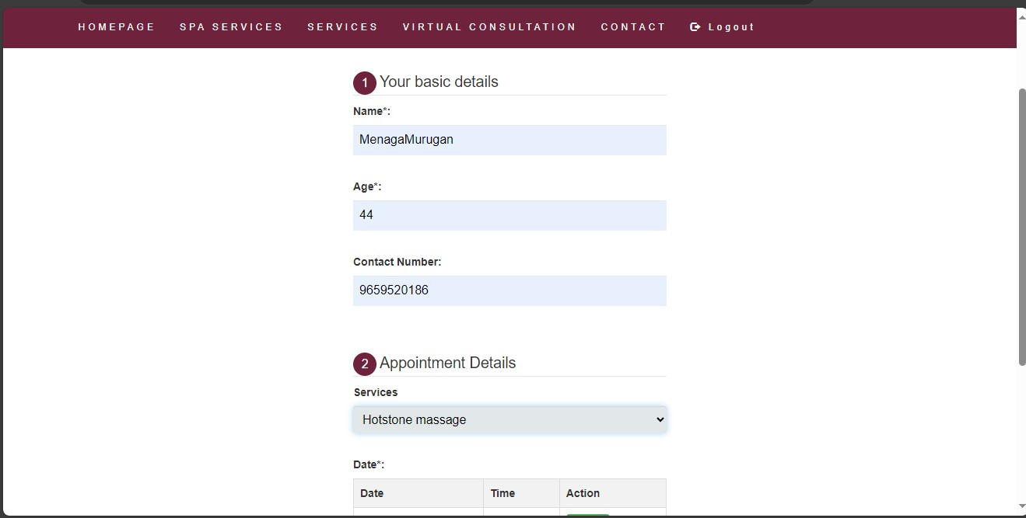**BOOKING SLOT:**

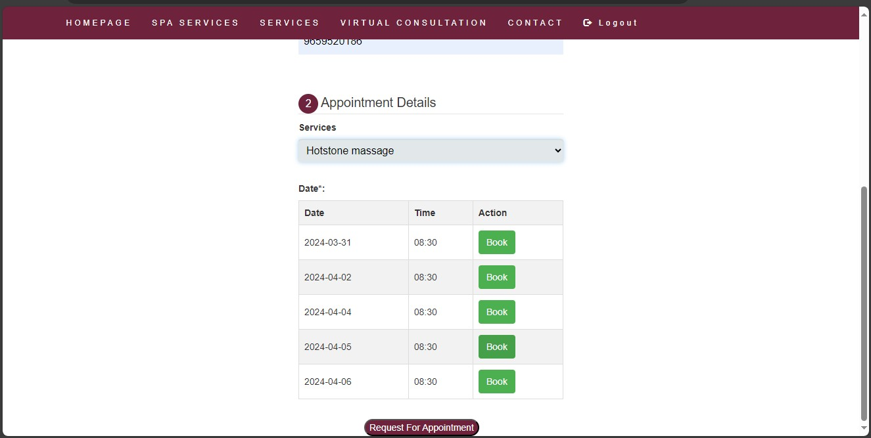

**APPOINTMENT BOOKED SUCCESSFULLY:**

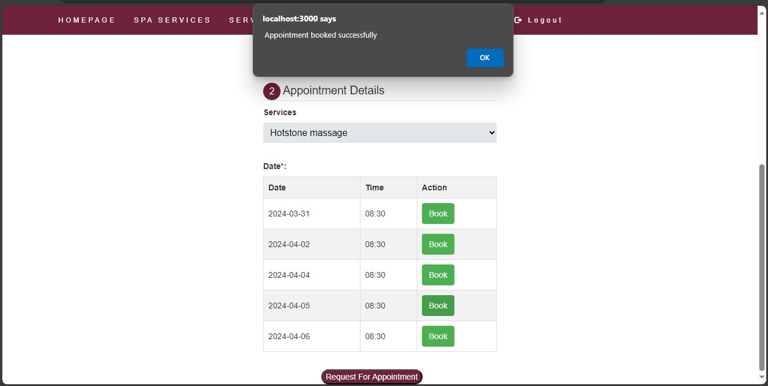**ONCE WE CLICKED OK BUTTON IT WILL TAKE US TO SPA SERVICE PAGE:**

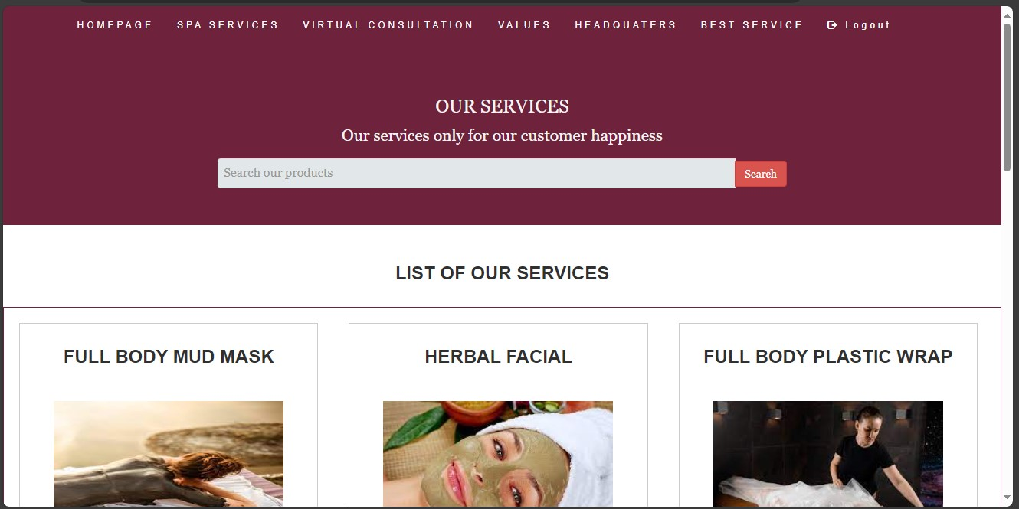

**SAME AS VIRTUAL CONSULTATION:**

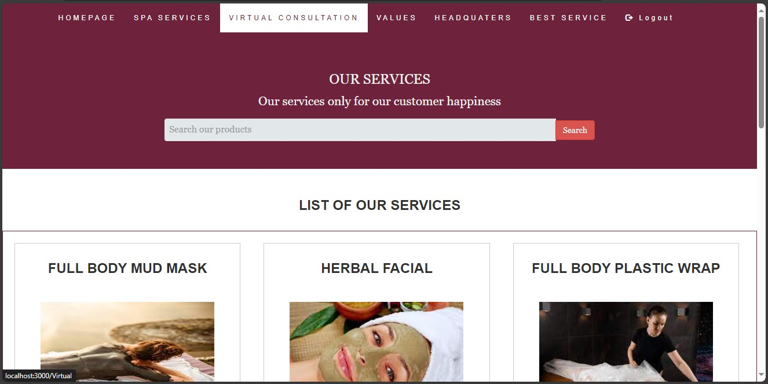

**VIRTUAL CONSULTATION APPOINTMENT PAGE:**

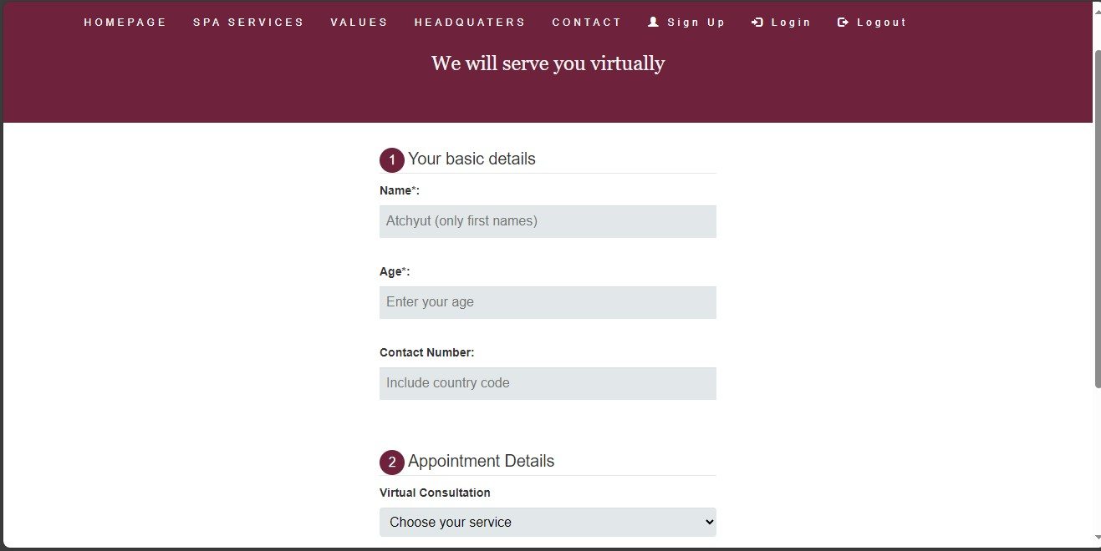

**CHOOSE YOUR VIRTUAL SERVICE:**

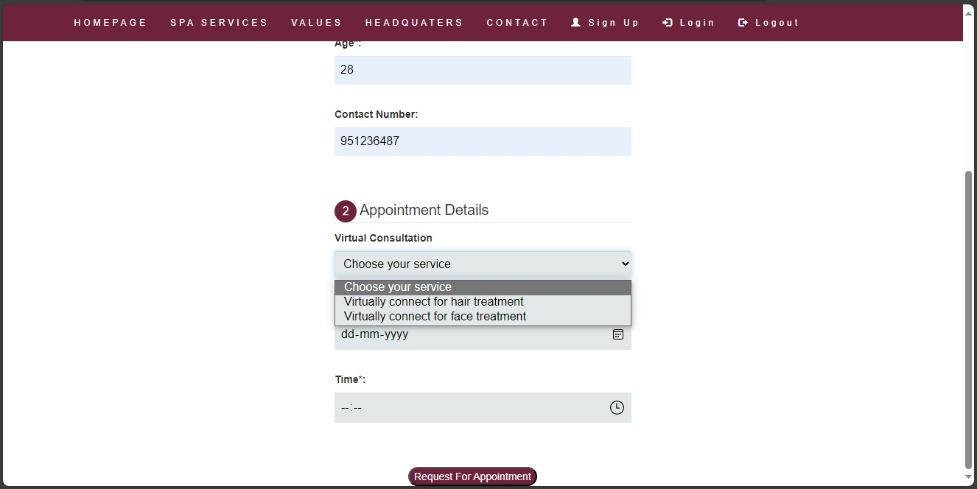**ONCE YOU BOOKED YOU CAN LOG OUT:**

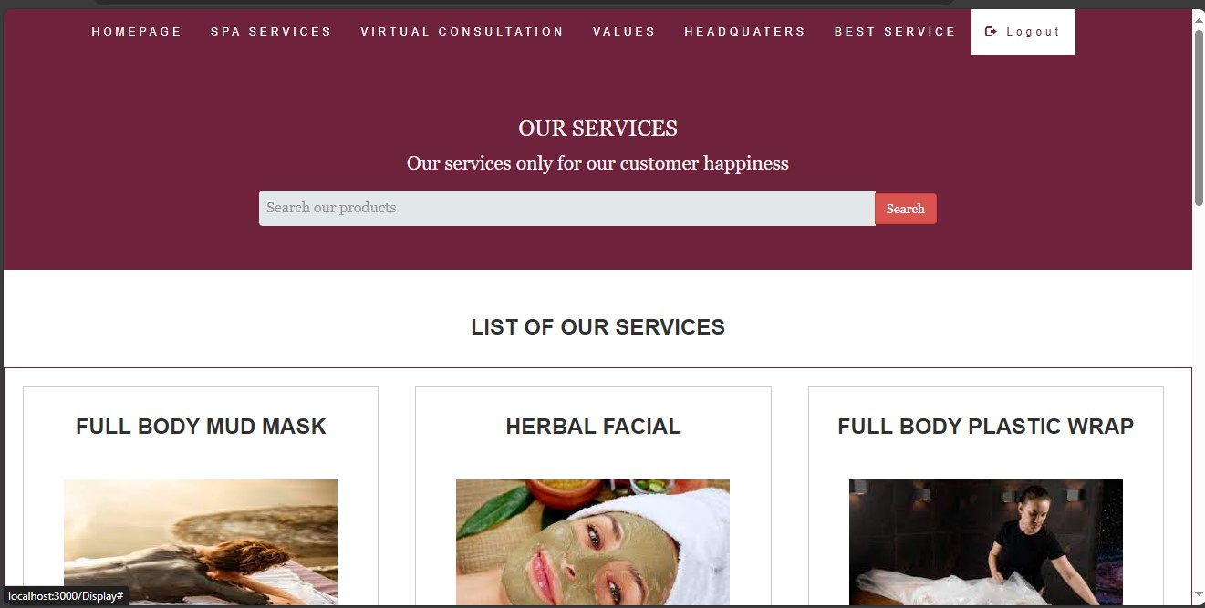

**ADMIN SIGN IN:**

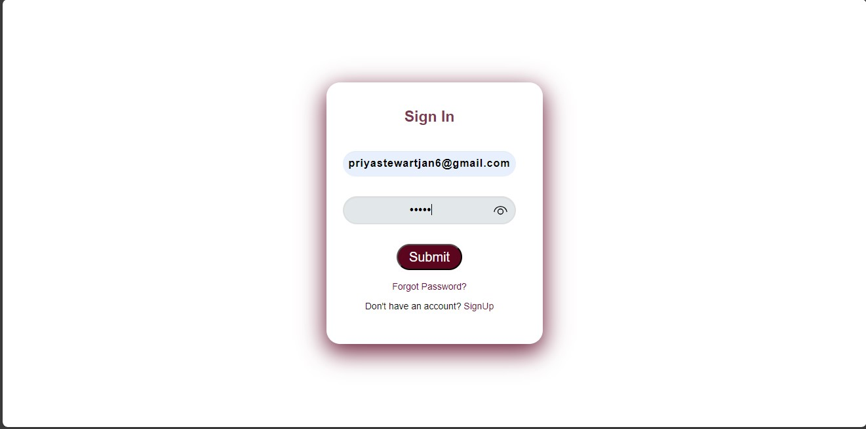

**ADMIN HOMEPAGE:**

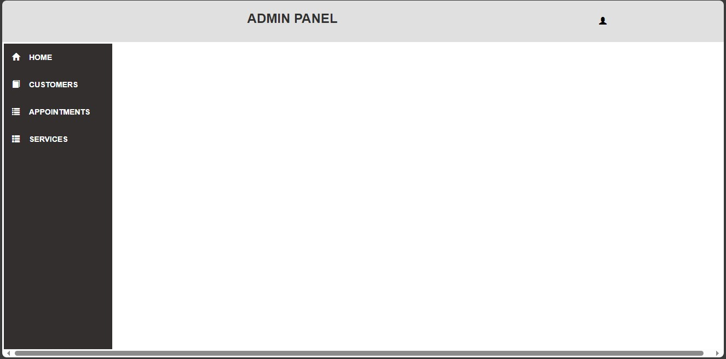

**IF WE CLICKED APPOINTMENTS:**

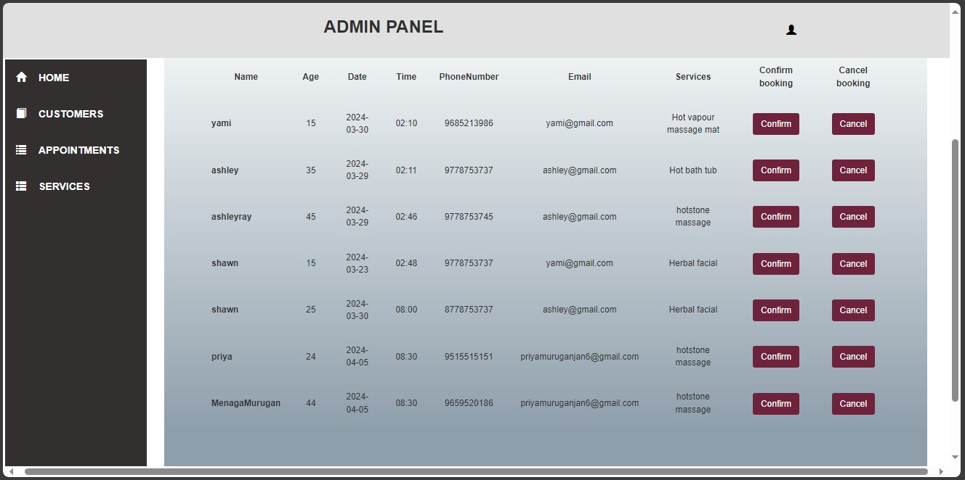

**IF WE CLICK CONFIRM ON CLIENT MENAGAMURUGAN IT WILL SENT MAIL TO THEIR EMAIL ABOUT THEIR CONFIRMATION:**

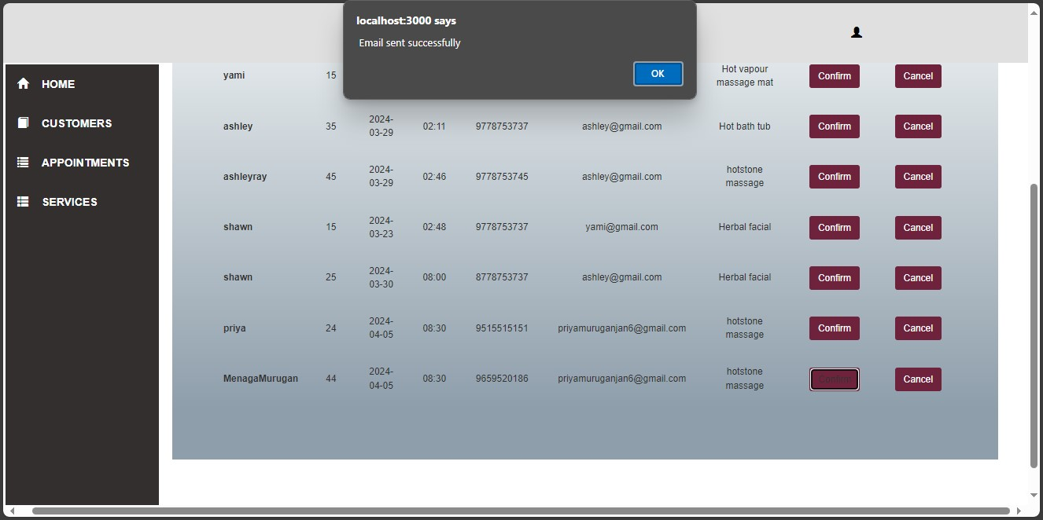

**CONFIRMATION MAIL:**

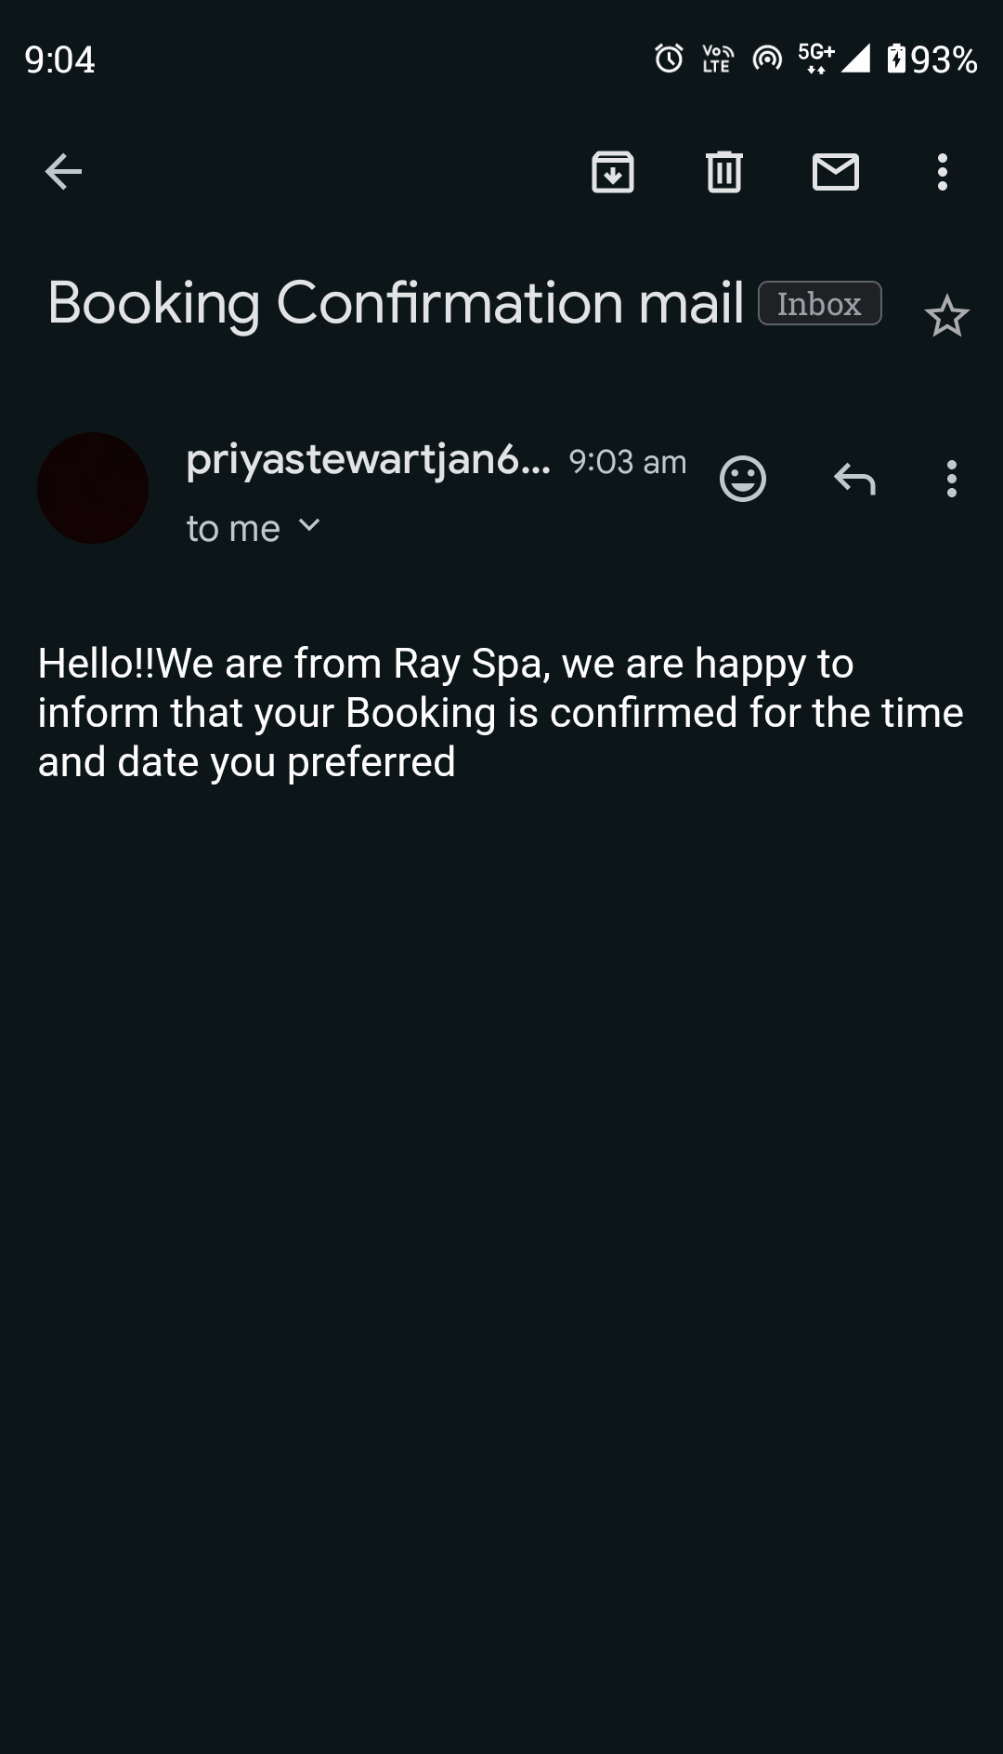

**IF WE CANCEL APPOINTMENT:**

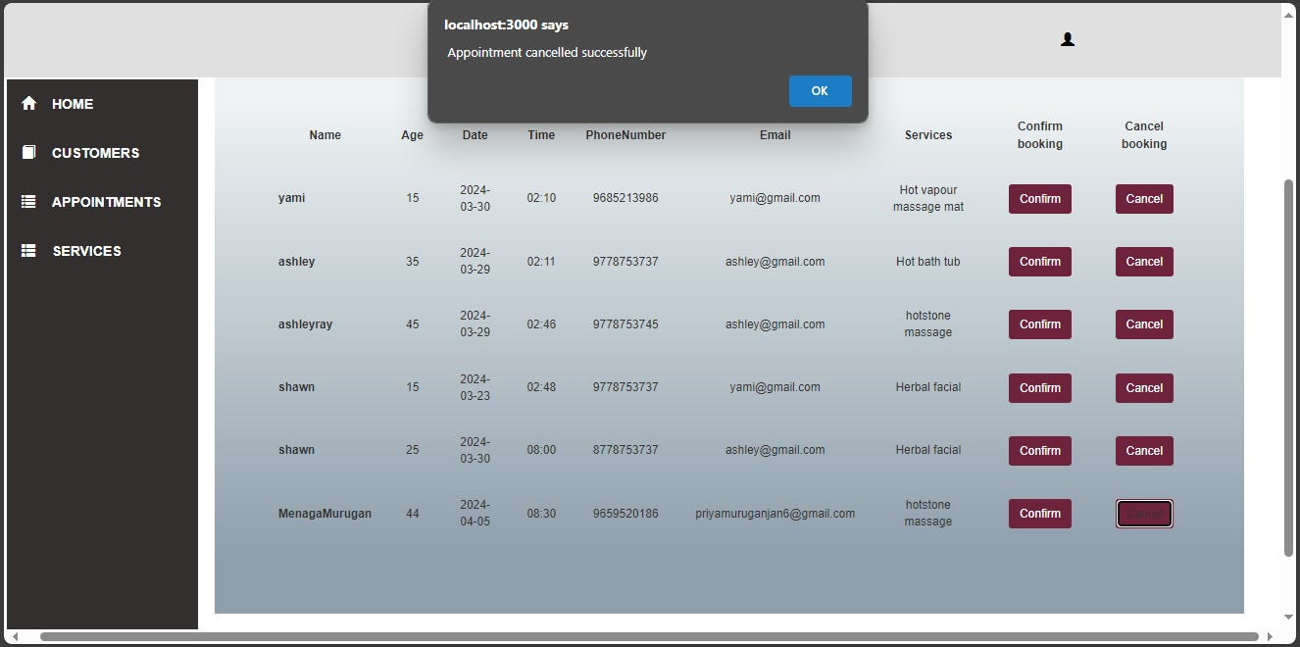**CANCELATION EMAIL:**

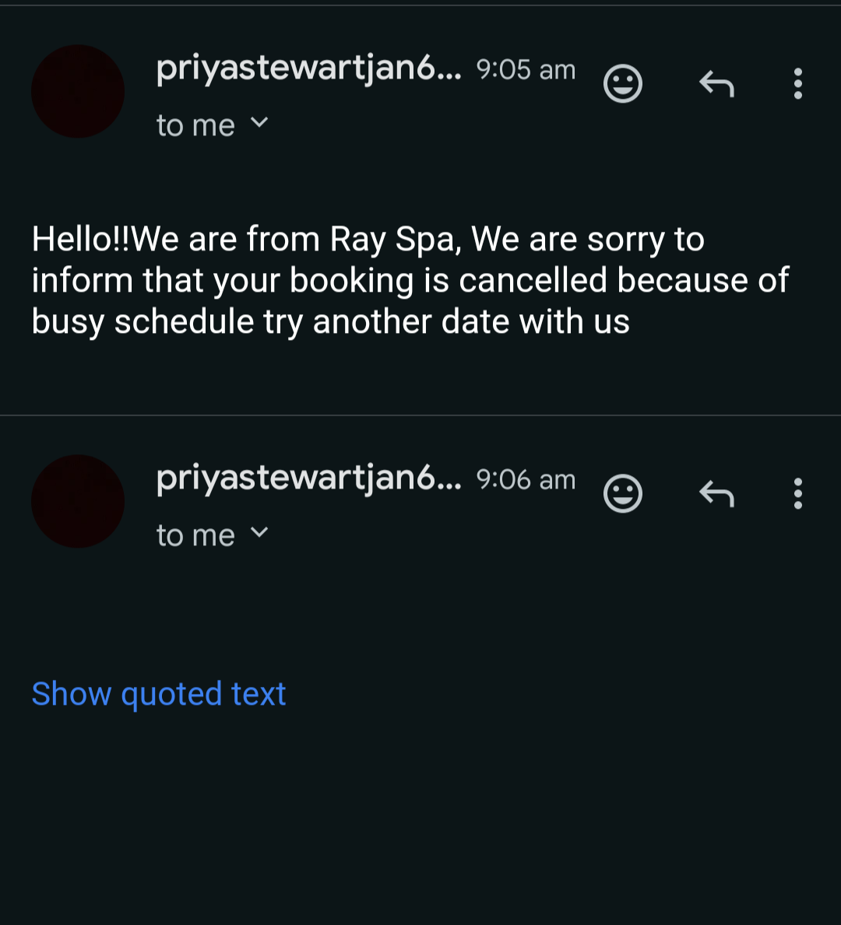

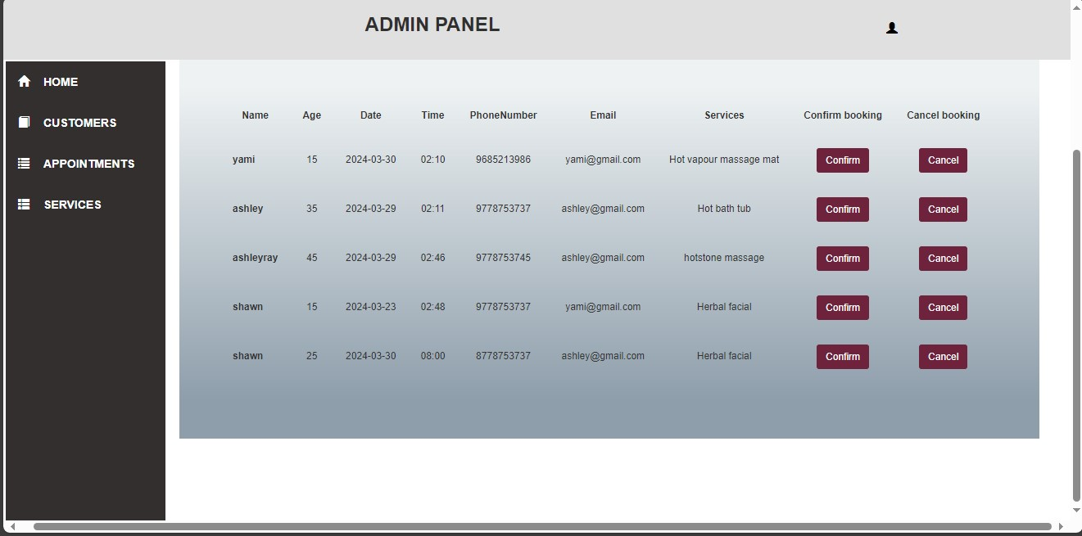

**IF WE CLICK** **CUSTOMERS,IT WILL SHOW ALL THE CUSTOMER DETAILS:**

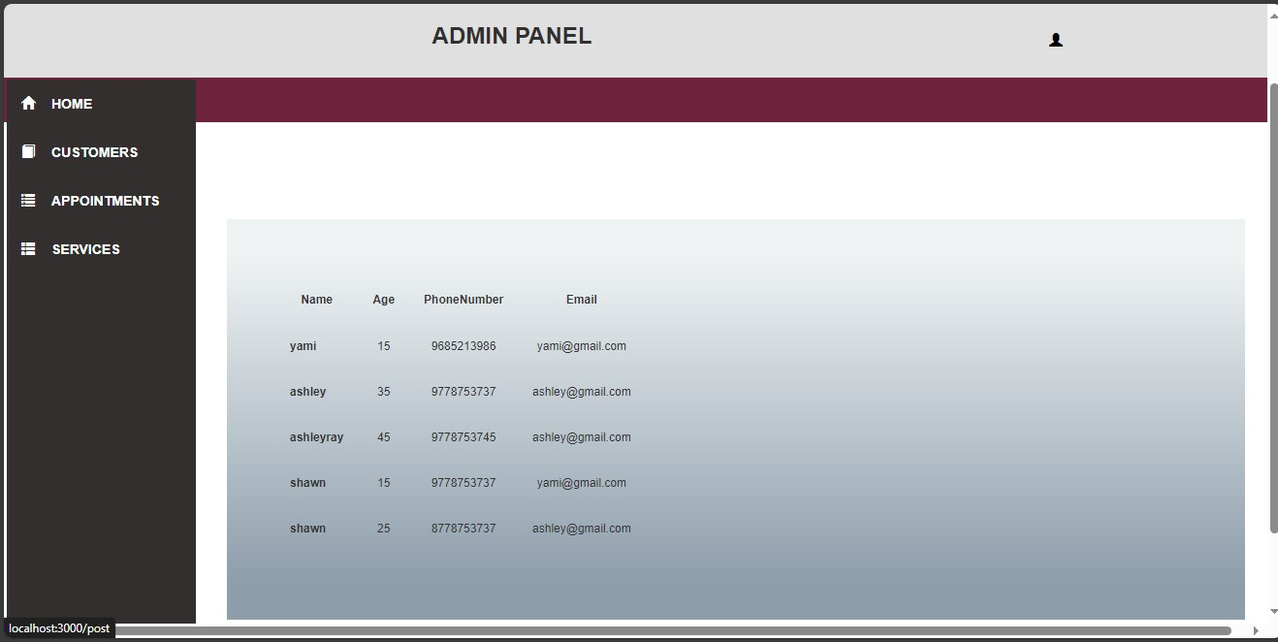

**IF WE CLICK ON SERVICES:**

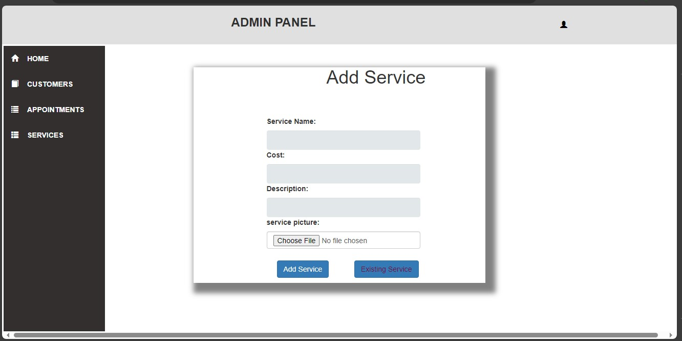**ADD SERVICE WE WANT:**

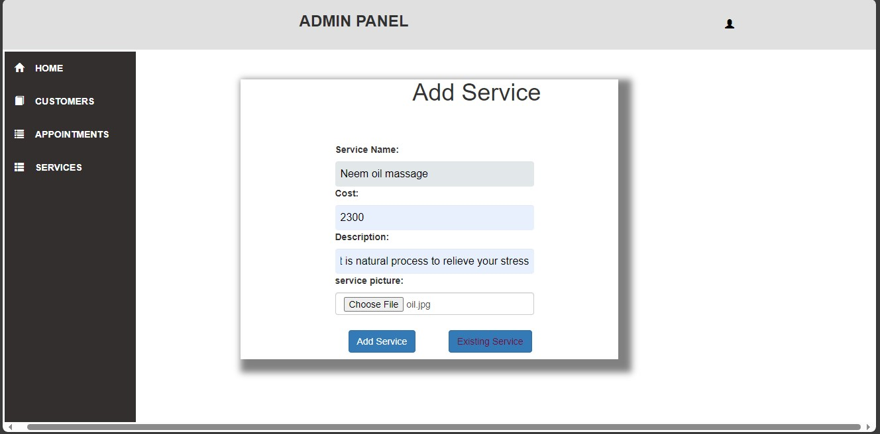

**HERE WE ADDED NEEM OIL MASSAGE:**

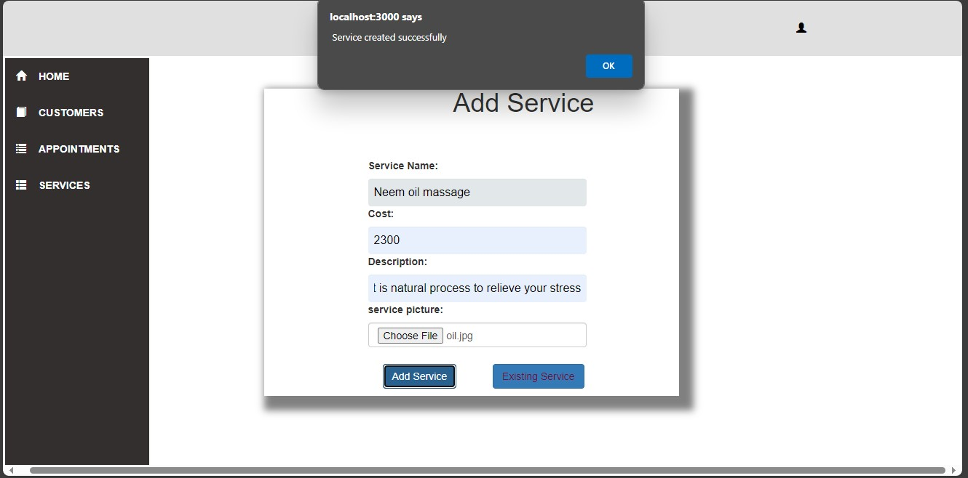**NEEM OIL MASSAGE ADDED:**

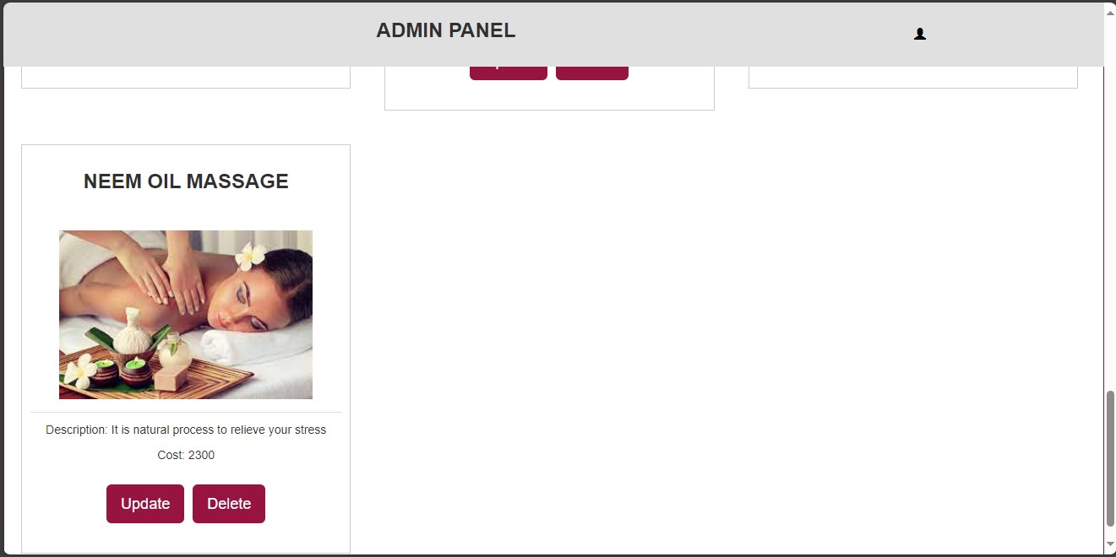

**IF WE UPDATE THE COST OF NEEM OIL MASSAGE:**

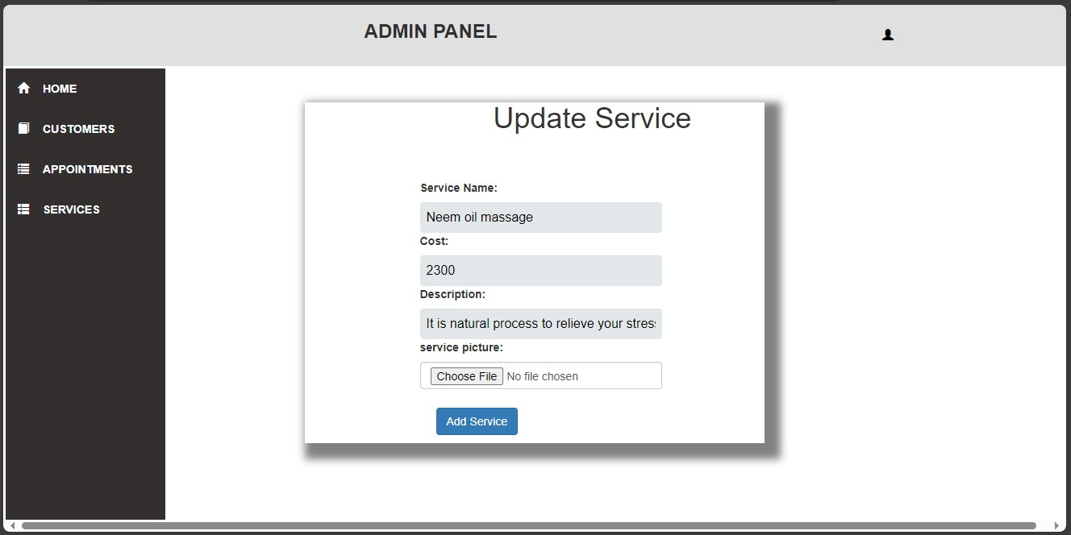

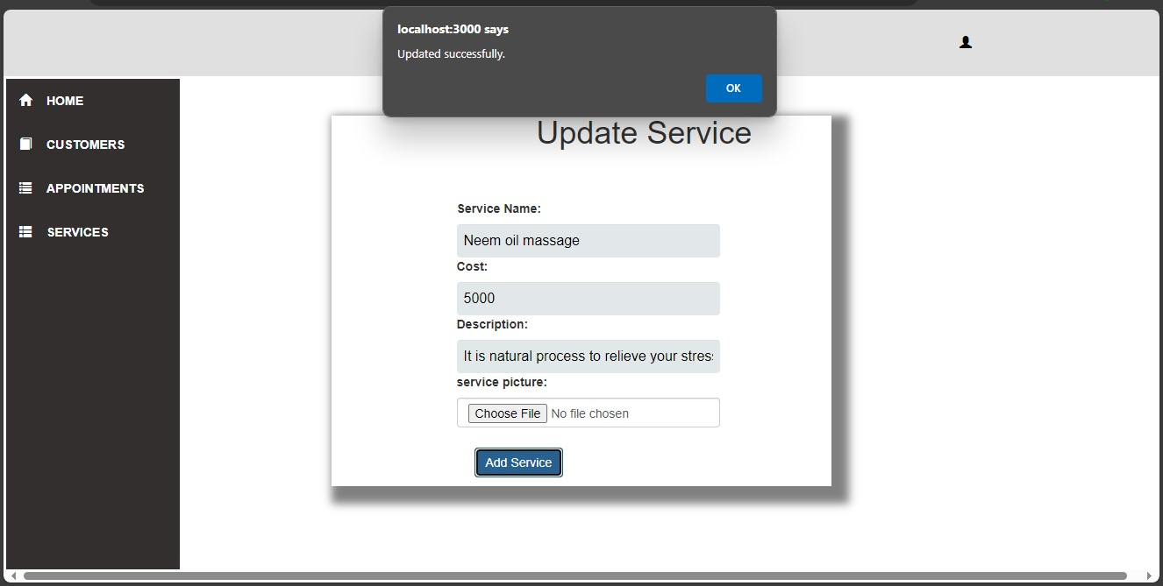

**COST IS UPDATED AS “5000”**

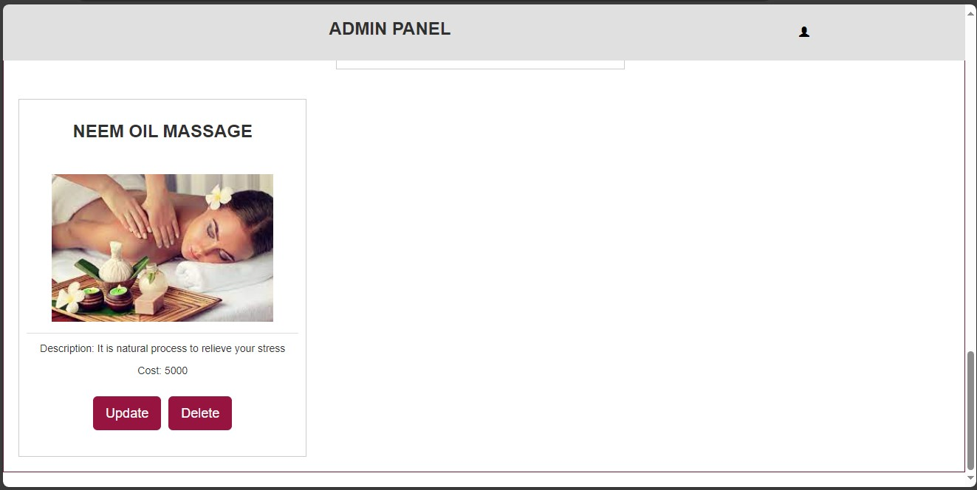

**CLICK DELETE ON THAI MASSAGE:**

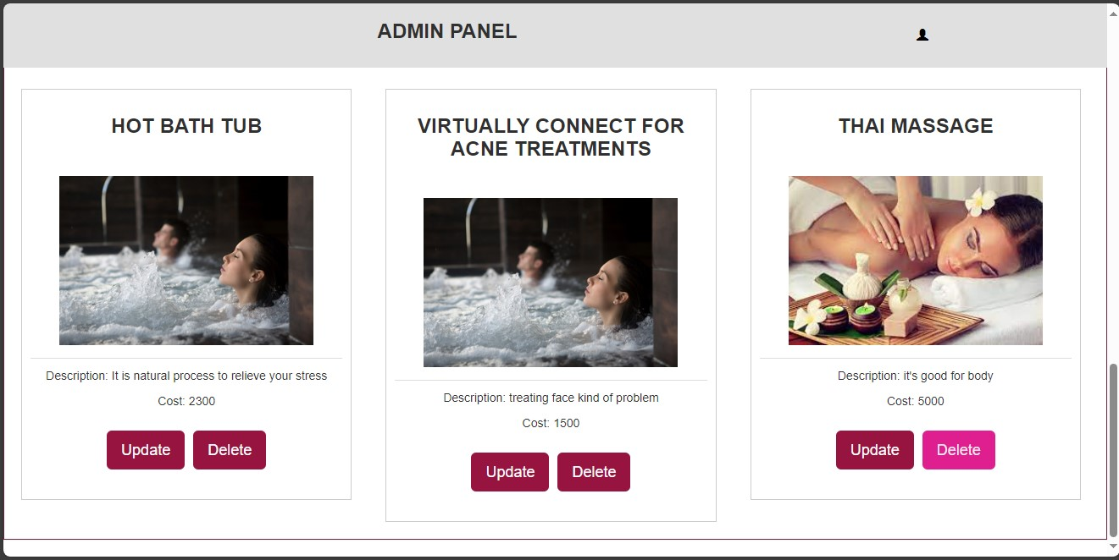

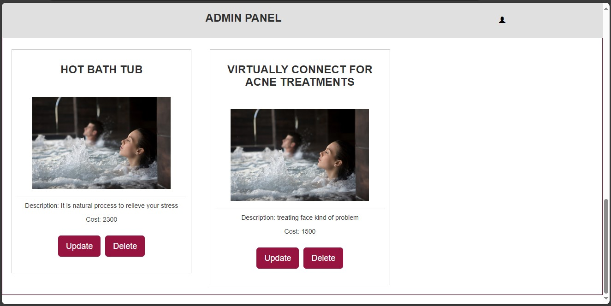**IF WE CLICK HOME ON ADMIN PANEL:**

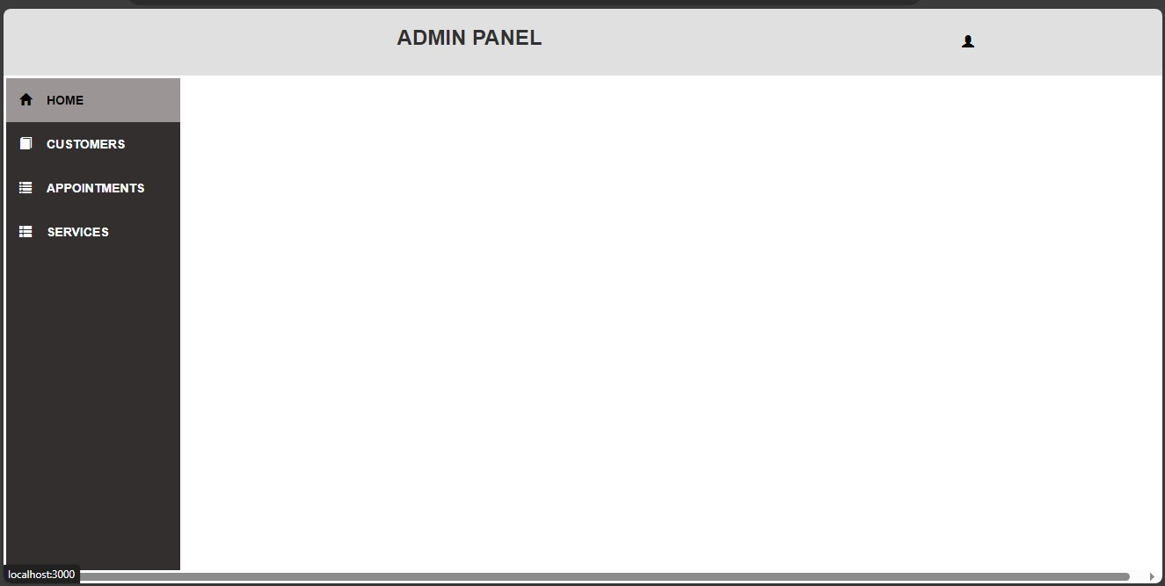

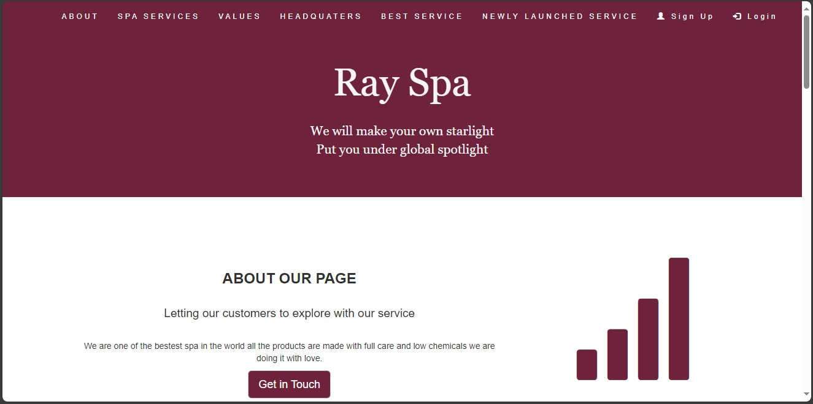**DATABASE AND TABLES:**

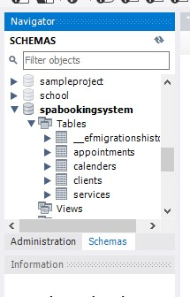

**APPOINTMENT TABLES:**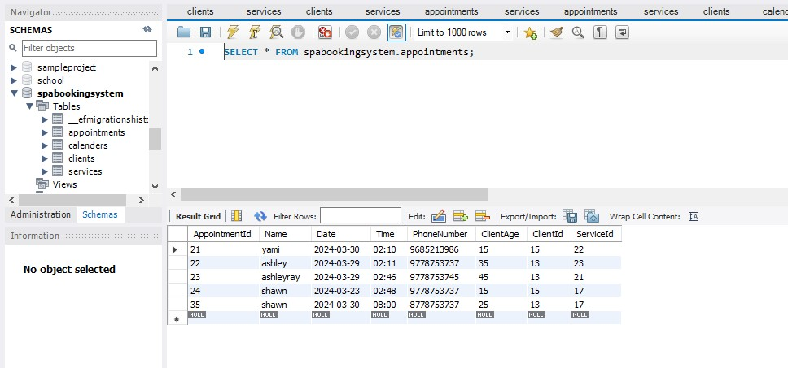

**CALENDER TABLES:**

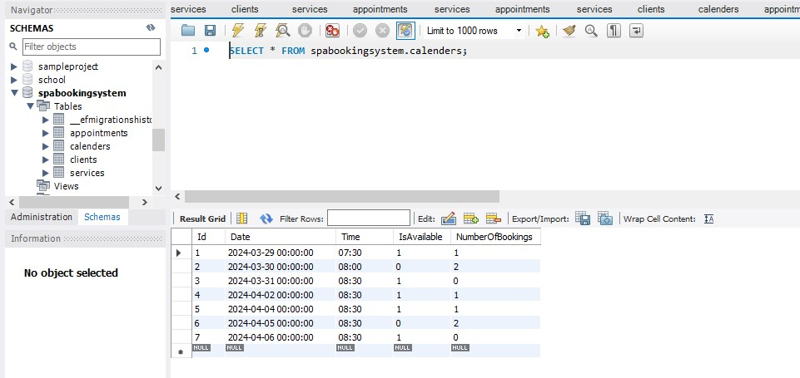

**CLIENTS TABLE:**

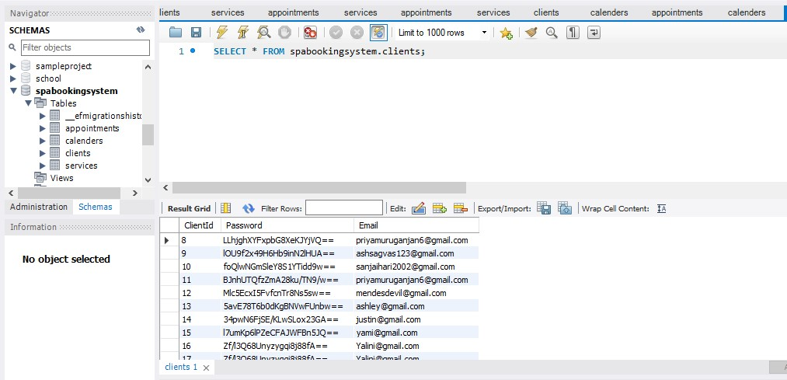

**SERVICES TABLE:**

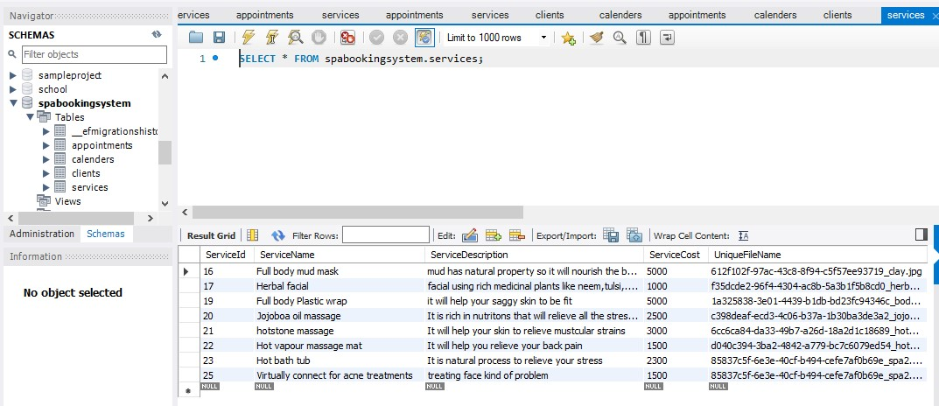

**CODE QUALITY:**

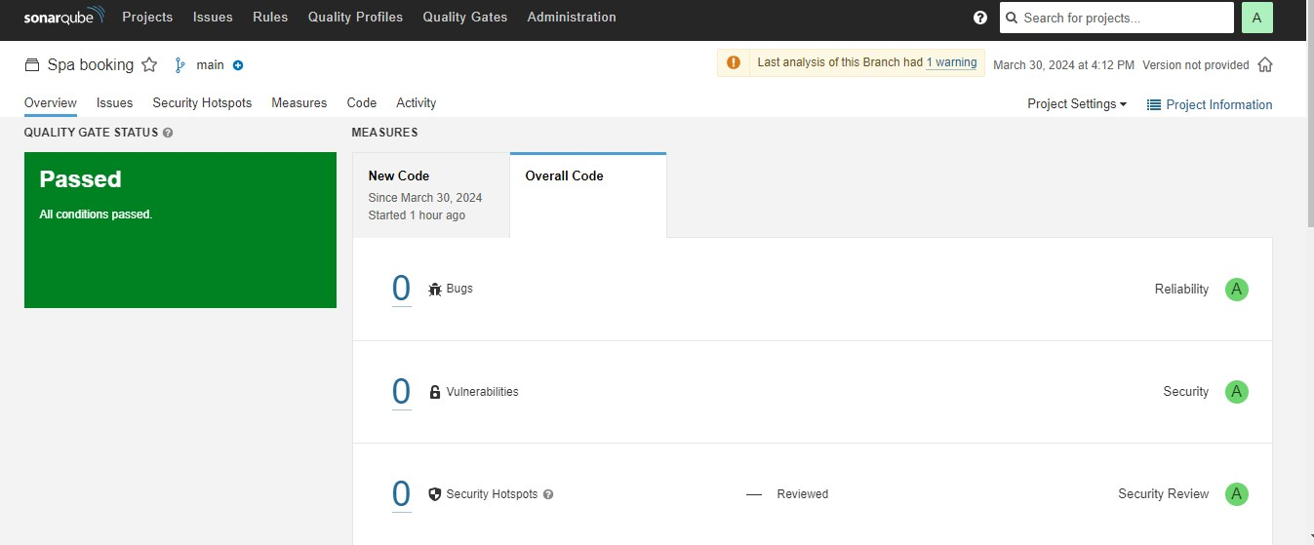

**TESTING:**

**JEST:**

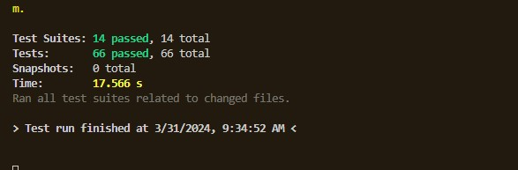

**NUNIT:**

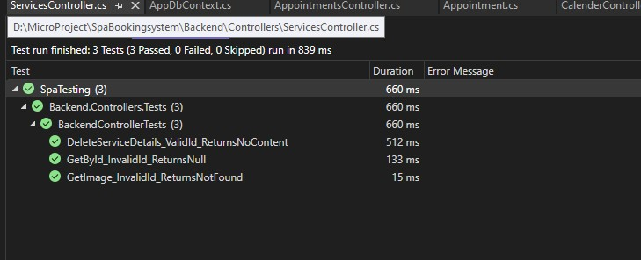

**SELENIUM TESTING:**

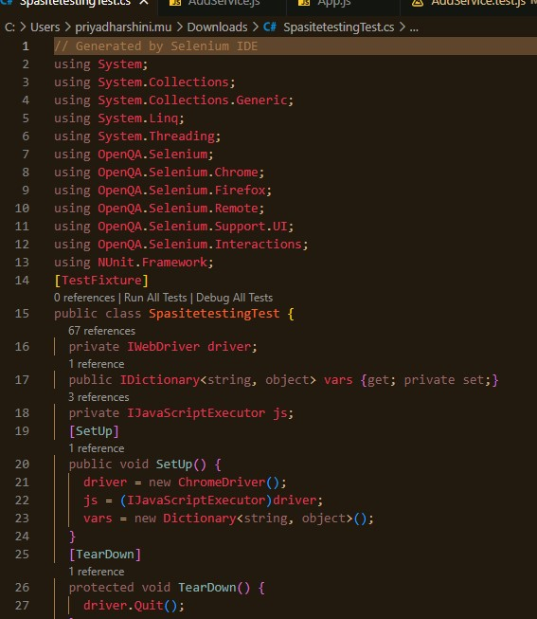

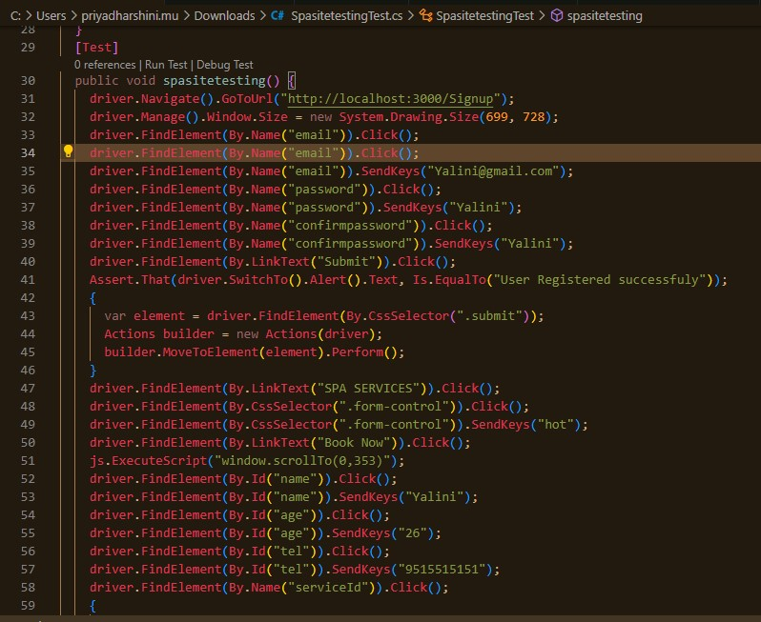

**DOCKER:**

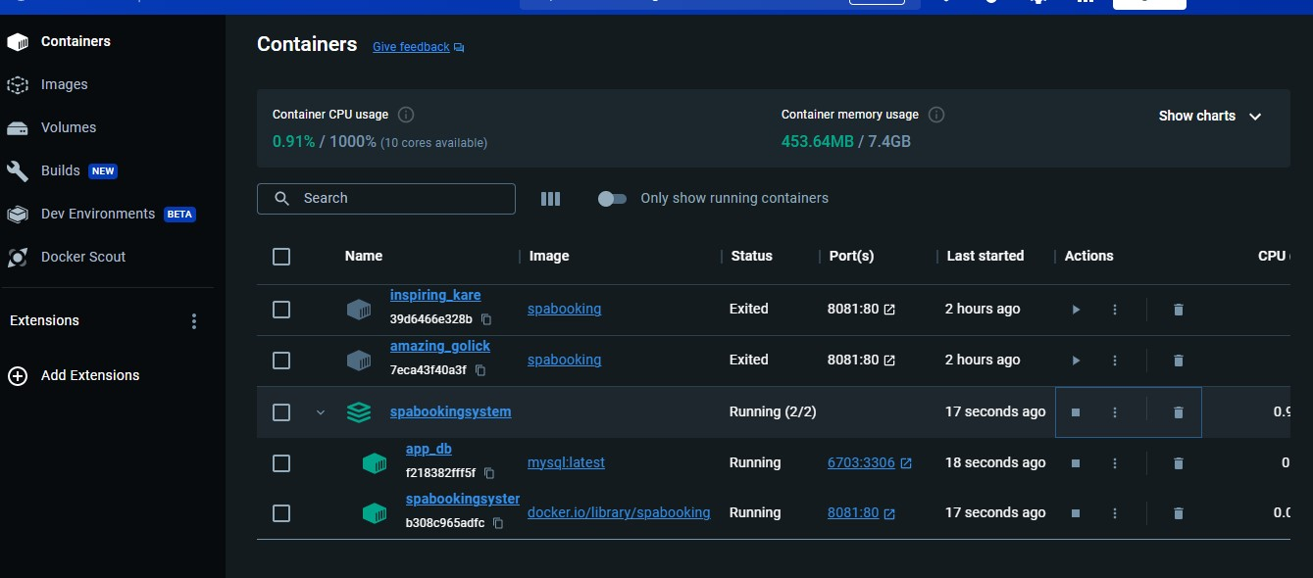**JENKINS FOR FRONTEND:**

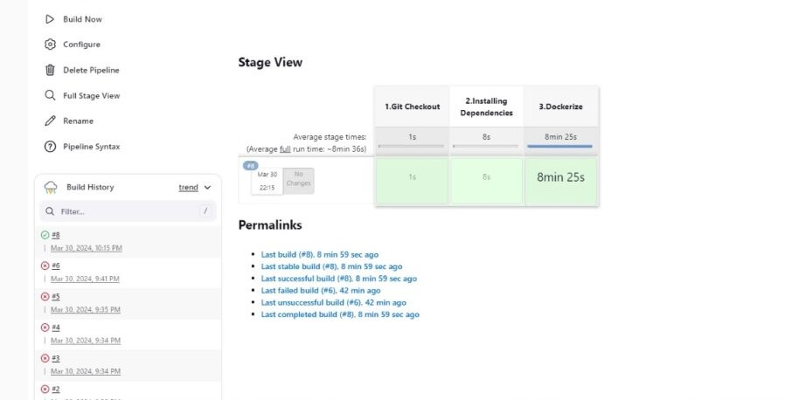

**JENKINS FOR BACKEND:**

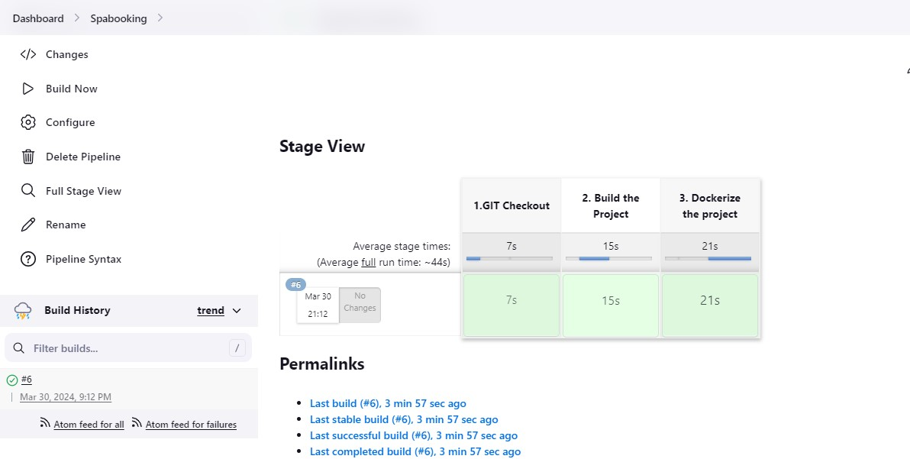

**GIT REPOSITORY:**

**FOR FRONTEND:**

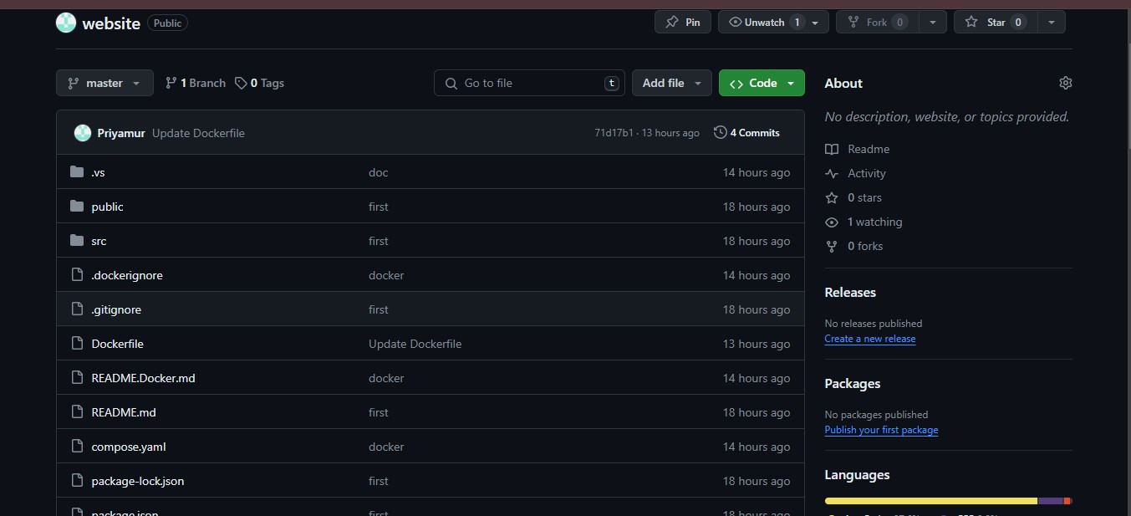

**FOR BACKEND:**

